USE pizza_hut;
SELECT * FROM pizzas;
SELECT * FROM pizza_types;
SELECT * FROM Orders;
SELECT * FROM order_details;

--Basic:
--1. Retrieve the total number of orders placed.
SELECT
COUNT(order_id) AS total_number_of_orders_placed
FROM
Orders;

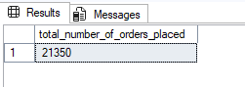

--2. Calculate the total revenue generated from pizza sales.
SELECT
CAST(SUM(od.quantity * p.price) AS DECIMAL(10,2)) AS total_revenue
FROM
order_details AS od
JOIN
pizzas AS p
ON od.pizza_id = p.pizza_id;

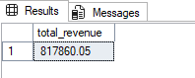

--3. Identify the highest-priced pizza.
SELECT TOP 1
pt.name AS pizza_type,
CAST(p.price AS DECIMAL(10,2)) AS price
FROM
pizza_types AS pt
JOIN
pizzas AS p
ON pt.pizza_type_id = p.pizza_type_id
ORDER BY
p.price DESC;

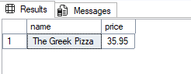

--4. Identify the most common pizza size ordered.
SELECT
p.size,
COUNT(od.quantity) AS quantity
FROM
pizzas AS p
JOIN
order_details AS od
ON p.pizza_id = od.pizza_id
GROUP BY
p.size
ORDER BY
quantity DESC;

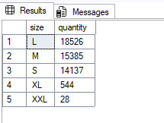

--5. List the top 5 most ordered pizza types along with their quantities.
SELECT TOP 5
pt.name AS pizza_type,
SUM(od.quantity) AS quantity
FROM
pizza_types AS pt
JOIN
pizzas AS p
ON pt.pizza_type_id = p.pizza_type_id
JOIN
order_details AS od
ON p.pizza_id = od.pizza_id
GROUP BY
pt.name
ORDER BY
quantity DESC;

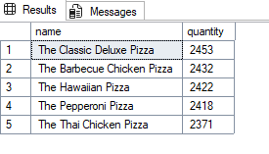

--Intermediate:
--6. Join the necessary tables to find the total quantity of each pizza category ordered.
SELECT
pt.category,
SUM(od.quantity) AS quantity
FROM
pizza_types AS pt
JOIN
pizzas AS p
ON pt.pizza_type_id = p.pizza_type_id
JOIN
order_details AS od
ON p.pizza_id = od.pizza_id
GROUP BY
pt.category
ORDER BY
quantity DESC;

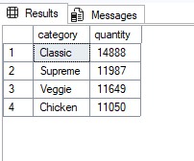

--7. Determine the distribution of orders by hour of the day.
SELECT
DATEPART(HOUR, time) AS hour,
COUNT(order_id) AS orders
FROM
Orders
GROUP BY
DATEPART(HOUR, time)
ORDER BY
DATEPART(HOUR, time);

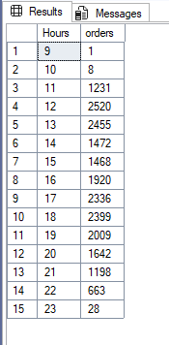

--8. Join relevant tables to find the category-wise distribution of pizzas.
SELECT
category,
COUNT(name) AS total_pizza_types
FROM
pizza_types
GROUP BY
category
ORDER BY
total_pizza_types DESC;

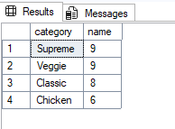

--9. Group the orders by date and calculate the average number of pizzas ordered per day.
SELECT
AVG(quantity) AS average_number_of_pizzas_ordered_per_day
FROM
(
SELECT
o.date AS date,
SUM(od.quantity) AS quantity
FROM
orders AS o
JOIN
order_details AS od
ON o.order_id = od.order_id
GROUP BY
o.date
) AS daily_order;

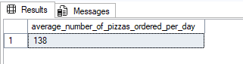

--10. Determine the top 3 most ordered pizza types based on revenue.
SELECT TOP 3
pt.name AS pizza_type,
CAST(SUM(p.price * od.quantity) AS DECIMAL(10,2)) AS total_revenue
FROM
pizza_types AS pt
JOIN
pizzas AS p
ON pt.pizza_type_id = p.pizza_type_id
JOIN
order_details AS od
ON p.pizza_id = od.pizza_id
GROUP BY
pt.name
ORDER BY
total_revenue DESC;

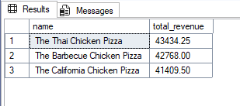

--Advanced:
--11. Calculate the percentage contribution of each pizza type to total revenue.
WITH cte AS (
SELECT
pt.category,
CAST(SUM(p.price * od.quantity) AS DECIMAL(10,2)) AS total_revenue
FROM pizzas AS p
JOIN pizza_types AS pt
ON p.pizza_type_id = pt.pizza_type_id
JOIN order_details AS od
ON p.pizza_id = od.pizza_id
GROUP BY pt.category
)
SELECT
category,
total_revenue,
CAST(total_revenue *100 / SUM(total_revenue) OVER () AS DECIMAL(10,2)) AS pct_revenue
FROM cte
ORDER BY
total_revenue DESC;

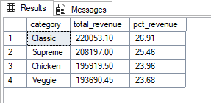

--12. Analyze the cumulative revenue generated over time.
WITH daily_revenue AS (
SELECT
o.date,
CAST(SUM(od.quantity * p.price) AS DECIMAL(10,2)) AS revenue
FROM
Orders AS o
JOIN
order_details AS od
ON o.order_id = od.order_id
JOIN
pizzas AS p
ON od.pizza_id = p.pizza_id
GROUP BY
o.date
)
SELECT
date,
SUM(revenue) OVER (ORDER BY date) AS cumulative_revenue
FROM
daily_revenue
ORDER BY
date ASC;

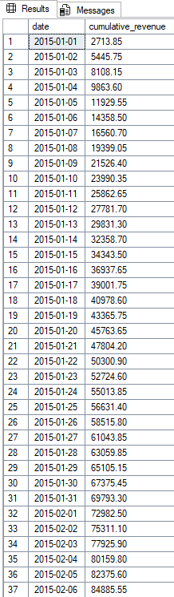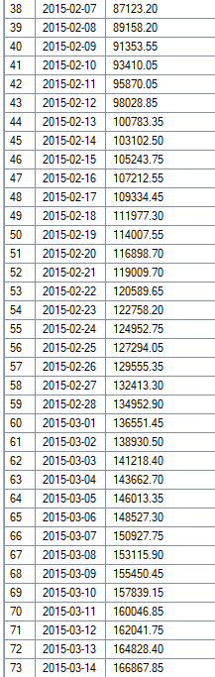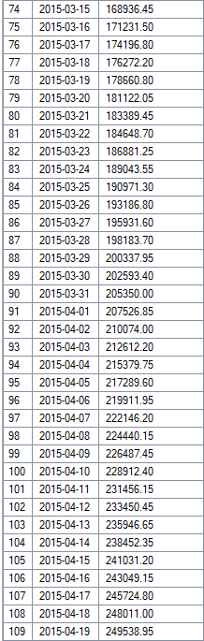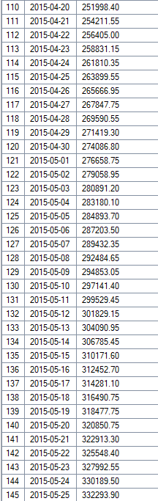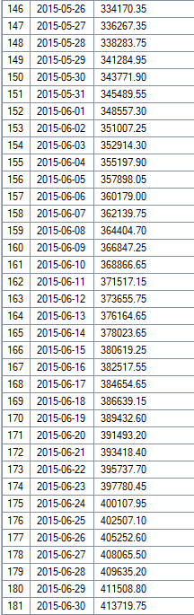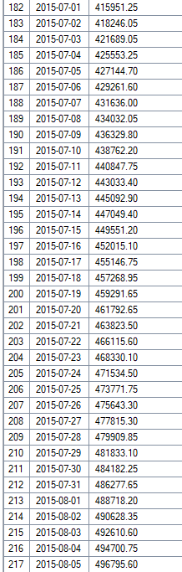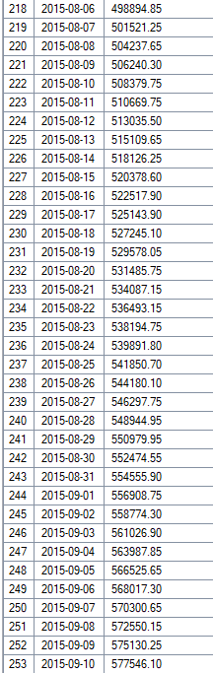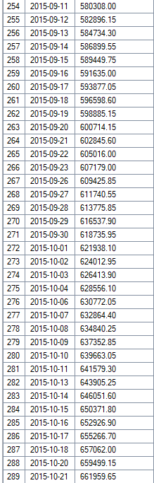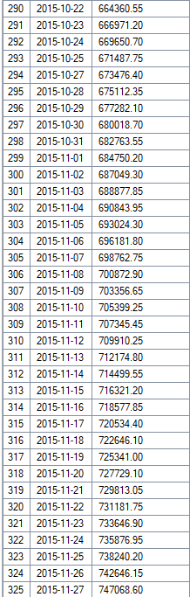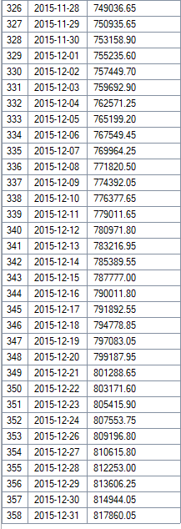

--13. Determine the top 3 most ordered pizza types based on revenue for each pizza category.
WITH revenue_by_type AS (
SELECT
pt.category,
pt.name AS pizza_type,
SUM(od.quantity * p.price) AS revenue
FROM order_details AS od
JOIN pizzas AS p ON od.pizza_id = p.pizza_id
JOIN pizza_types AS pt ON p.pizza_type_id = pt.pizza_type_id
GROUP BY pt.category, pt.name
),
ranked AS (
SELECT
category,
pizza_type,
revenue,
ROW_NUMBER() OVER (PARTITION BY category ORDER BY revenue DESC, pizza_type ASC) AS rn
FROM revenue_by_type
)
SELECT
category,
pizza_type,
CAST(revenue AS DECIMAL(10,2)) AS revenue
FROM ranked
WHERE rn <= 3
ORDER BY category, revenue DESC;
